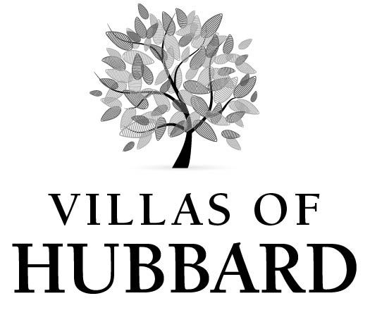
222 South Magnolia Avenue
Hubbard, Texas 76648
Phone: (254) 576-1004 ▪ Fax: (254) 576-1094

<DATE>

<Recipient>
<Recipient Address><Unit#>
<Recipient City, State and Zip>

RE: <SUBJECT>

Dear Ms. / Mr. <Last Name of Recipient>,

Thank you,

<Property Manager Name>
Property Manager

