Documenting Special Needs / Disabled Households in OneSite
Follow the instructions below for any household member that claims “Yes” on the Special Needs Certification form, has a DI or HA near the social security number on any social security verification, a clarification record explaining a resident’s disability, or a letter from a doctor requesting reasonable accommodation.
Step 1: Under the Resident tab, locate the household and open the Resident View screen.
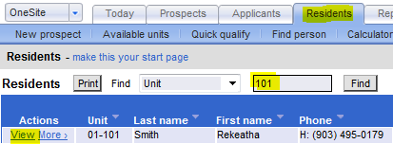

Step 2: Under the Resident view screen, click Edit near the name of the Disabled household member.
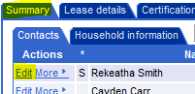

Step 3: A new window will appear. Under the Demographics tab, check the type of relevant disability (i.e. – only one), and click “Save” at the bottom of the screen.
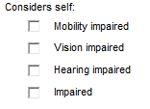

Step 4: Under the first page of the Interview, mark if the household is “Disabled” or “Elderly and Disabled”, then click Next at the bottom of the page to save. Recall, Elderly according to TDCHA is at least sixty years of age.
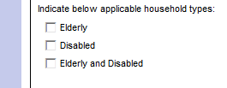

That’s it! The household member and the unit will now be recorded as Special Needs & Disabled.

Please contact your compliance supervisor directly if you have any questions about a specific household.

